Working in the Cloud

with ClearMedia Academy

Opening ClearMedia VM Console

**Microsoft Edge (Chromium)**

* Download & Install the new Microsoft Edge (Chromium) version
  + Install CHOCOLATEY cfr Website chocolatey.org
  + choco install microsoft-edge
  + choco install vmrc
* Surf to <https://my.bizzcloud.be/tenant/Cleartoso> (Replace Cleartoso with your Org name)
* Open the correct vDC
* Either click on the 3 dots of any online VM or on “Actions”. In the middle of this menu you can find “VM Console “ and then right of it “Launch Web Console” or “Launch Web Console”

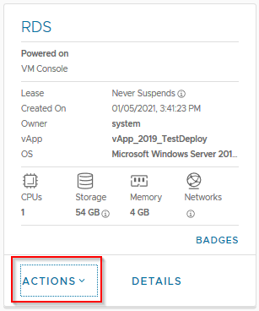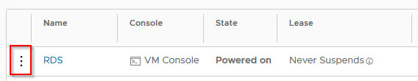

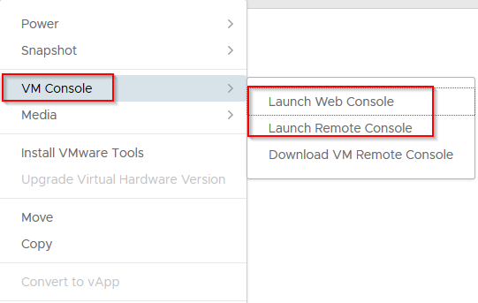

* For the “Web Console” you do not need any plugins
* It will ask to download and install the plugin when you use VMRC for the first time
* Alternatively you can download it via: <https://www.vmware.com/go/download-vmrc>

**Firefox**

* Download the newest Firefox version via this link: <https://www.mozilla.org/nl/firefox/all/#product-desktop-release>
* Just like Microsoft Edge, you do not need any extra plugins to use the Console via the “Web Console” option.
* Surf to <https://my.bizzcloud.be/tenant/Cleartoso> (Replace Cleartoso with your Org name)
* For the “VM Remote Console” option you need the VMware Remote Console plugin. The VMRC is useful for copy/paste in or out of the VM Console. However, be aware that the “Clipboard” is limited to 4MB. Larger files or data will crash the Console and you will have to reset (empty) the clipboard again.

**Chrome**

* Download the newest Chrome version via this link: <https://www.google.com/chrome/browser/desktop/index.html>
* Just like Microsoft Edge, you do not need any extra plugins to use the Console via the “Web Console” option.
* Surf to <https://my.bizzcloud.be/tenant/Cleartoso> (Replace Cleartoso with your Org name)
* For the “VM Remote Console” option you need the VMware Remote Console plugin. The VMRC is useful for copy/paste in or out of the VM Console. However, be aware that the “Clipboard” is limited to 4MB. Larger files or data will crash the Console and you will have to reset (empty) the clipboard again.